Memorandum

Date: 11 December 2009

To: SGHnet

From: Brian Twomey

Project: REVIT

Subject: Zero Dimension

Until recently, many of us have been struggling with showing 0” offsets in Revit. One common work-around was to do a text override with [0”.] in the text override box. This would leave a stray period on the drawings and look messy.

To show a zero dimension for offset conditions, do the following:

- Duplicate the dimension type you would like to use in the dimension type properties window. Name it something clever like “Zero Dim.”
- Click on the box to the right of the “Units Format” parameter line
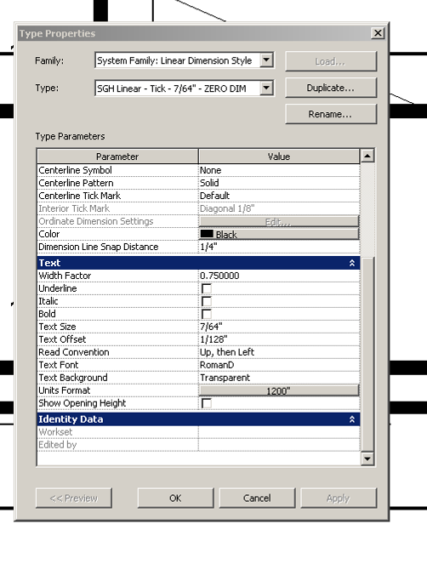

- Set the Units to “Decimal inches”
- Set Rounding to “To the nearest 1000”
- Set the Unit symbol to “””
- Click the box next to “Suppress trailing 0’s”
- Click “OK”
